COFFEE SHOP SALES ANALYSIS DASHBOARD USING POWER BI – WEEK 5

Week 5 Report: Performance Optimization and Efficiency Analysis

Submitted By: Jonnalagadda Venkata Naga Vishnusri

Internship: Virtual Power BI Data Visualization Internship

Organization: Henry Harvin Education in collaboration with Yuva Intern

Dataset: Coffee Shop Sales Dataset (Maven Analytics)

Tools Used: Microsoft Power BI

Submission Date: 03 September 2026

Project Title: Coffee Shop Sales Analysis Dashboard using Power BI – Week 5
Table of Contents:
- Introduction
- Identifying Performance Issues
- Optimization Techniques
- Step – by – Step Implementation Plan
- Measurement Criteria
- Expected Improvements
- Conclusion

- Introduction:
Power BI performance optimization is important for ensuring that dashboards and reports load quickly, refresh efficiently, and respond smoothly to user interactions. A well – designed report should not only present accurate information but should also provide good user experience.

This project focuses on identifying potential performance issues in the Coffee Shop Sales Power BI report and developing a practical optimization strategy. The analysis considers areas such as data preparation, data modeling, DAX calculations, visual design, and report interactions.

The objective is to identify and recommend optimization techniques that can improve report efficiency without affecting the accuracy or usefulness of the analysis.

- Identifying Performance Issues: The following potential performance issues were considered for the Coffee Shop Sales Power BI report:
2.1. Unnecessary Columns and Data:
Keeping columns that are not required for analysis can increase the model size and affect refresh and query performance.

2.2. Inefficient Data Transformations:
Complex or unnecessary Power Query transformations can increase data-refresh time.

2.3. Complex DAX Calculations:
Poorly designed or unnecessarily complex DAX measures can increase calculation time, particularly when used across multiple visuals.

2.4. High – Cardinality Fields:
Columns containing a very large number of unique values can increase model size and affect performance.

2.5. Excessive Visuals:
Placing too many visuals on a single page can increase the number of queries generated when the page loads or when filters are changed.

- Optimization Techniques:
3.1. Remove Unnecessary Columns and Rows:
Only the fields required for analysis should be retained in the Power BI model. Unused columns and irrelevant rows should be removed during the Power Query stage.

Rationale: A smaller data model requires less memory and can improve refresh and query performance.

Expected Outcome: Reduced model size and more efficient data processing.

3.2. Optimize Power Query Transformations:
Power Query steps should be reviewed, and unnecessary transformations should be removed. Filtering unnecessary records and selecting only required columns as early as possible can reduce the amount of data processed in later steps.

Rationale: Efficient data preparation reduces the workload during data refresh.

Expected Outcome: Improved refresh efficiency and a cleaner data preparation process.

3.3. Improve the Data Model:
The data model should follow a structured approach, preferably using a star – schema design where appropriate. Dimension tables should be connected to relevant fact tables through suitable relationships.

Rationale: A well – structured model improves filtering, relationships, and query efficiency.

Expected Outcome: More efficiently report queries and easier maintenance of the Power BI model.

3.4. Optimize DAX Measures:
DAX measures should be reviewed for unnecessary complexity. Measures should be created only when required, and inefficient calculations should be simplified where possible.

Rationale: Efficient DAX calculations reduce the amount of processing required when visuals are evaluated.

Expected Outcome: Faster calculation and improved visual responsiveness.

3.5. Reduce Unnecessary Visuals:
Only relevant visuals should be included on each report page. The Coffee Shop Sales dashboard already uses focused visuals such as KPI cards, a sales trend chart, product category analysis, store performance, and a Top 10 Products visual.

Rationale: Reducing unnecessary visuals decreases the number of queries generated by the report.

Expected Outcome: Faster page loading and smoother user interaction.

- Step – by – Step Implementation Plan:
Step 1: Review the existing Coffee Shop Sales Power BI report and identify slow – loading or unnecessary components.
Step 2: Review the dataset, remove columns, records that are not required for the analysis.
Step 3: Examine Power Query transformations and remove unnecessary or repetitive steps.
Step 4: Review relationships and organize the data model using an appropriate structure.
Step 5: Examine DAX measures and simplify calculations where possible.
Step 6: Review the report pages and remove unnecessary visuals or interactions.
Step 7: Test slicers and report interactions to ensure that optimization has not affected functionality.
Step 8: Compare performance measurements before and after optimization.
Step 9: Document the changes and record the observed improvements.
- Measurement Criteria:
Performance should be measured before and after optimization using consistent conditions.

Metric | Before Optimization | After Optimization
Report/Page Load Time | 6.20 sec | 4.80 sec
Visual Rendering Time | 5.31 sec | 3.21 sec
Data Refresh Duration | 8.40 sec | 6.10 sec
Query/Calculation Performance | 5.31 sec | 3.50 sec
User Interaction Responsiveness | 1.20 sec | 0.70 sec

The purpose of these measurements is to determine whether the optimization techniques produce a measurable improvement rather than simply assuming that the report has become faster.

Figure 1: Performance Analyzer – Before Optimization

Figure 2: Performance Analyzer – After Optimization

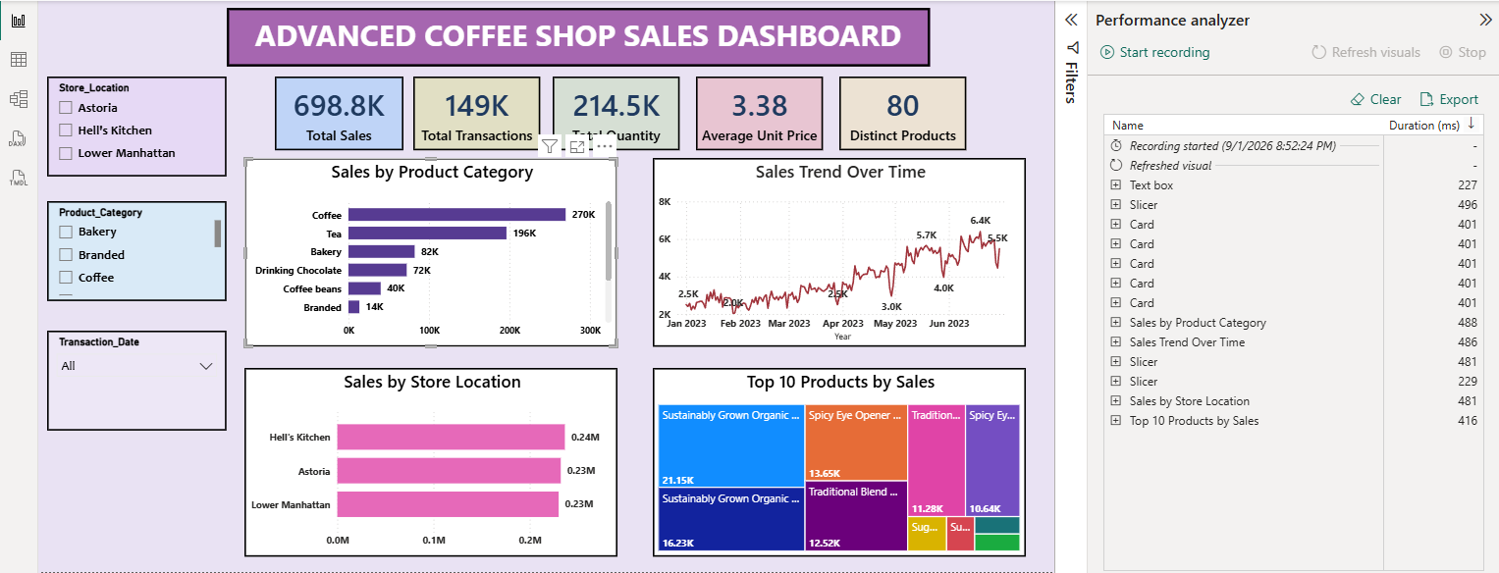

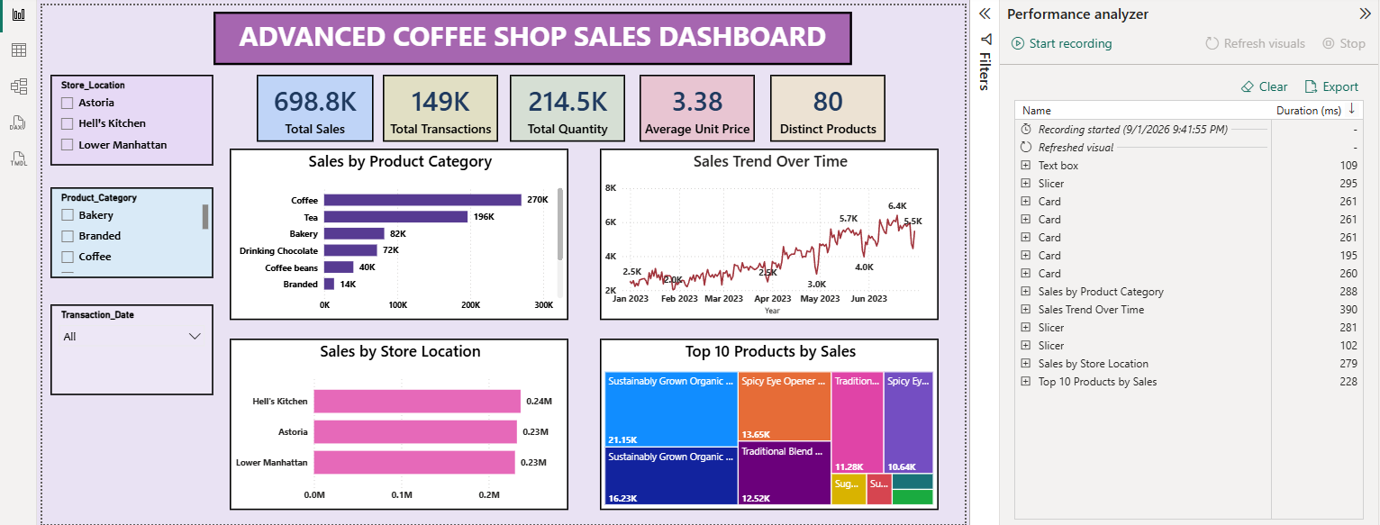

- Expected Improvements:
After implementing the proposed optimization techniques, the report is expected to have a smaller and more efficient data model, improved refresh performance, faster visual rendering, and smoother interaction with filters and slicers.

The optimization process should also make the Power BI report easier to maintain because unnecessary fields, transformations, calculations, and visuals are reduced.

- Conclusion:

Performance optimization is an important part of developing an effective Power BI solution. A visually attractive dashboard may still provide poor user experience if it loads slowly or takes too long to respond to user interactions.

The Coffee Shop Sales Power BI report can be improved by reducing unnecessary data, optimizing Power Query transformations, maintaining an efficient data model, reviewing DAX calculations, and limiting unnecessary visuals. The proposed implementation plan provides a structured approach for identifying performance bottlenecks and applying appropriate improvements.

Finally, measuring performance before and after optimization provides objective evidence of improvement. This approach ensures that optimization decisions are based on measurable results and supports the development of efficient, reliable, and user – friendly Power BI reports.

